PIE’s for Carers (Supporters)

Creating a supportive space for people with a mental health need and their supporters.
Otherwise called a Psychologically Informed environment (PIE).

Relationships 2 – Conflict and Crisis

Aim - Reducing and managing conflict and crises with the person you support who has lived experience of mental health issues

- Understanding challenging behaviour
- Circular arguments (Drama triangle) and de-escalation for conflict
- Keep everyone safe – managing a crises
- Non-listening & Listening activity
- PLACE – Playfulness, Love, Acceptance, Curiosity, Empathy
- I’m OK your OK – the aspiration
- Understanding The Vicious Cycle - Feelings, Behaviour, Body, Emotions

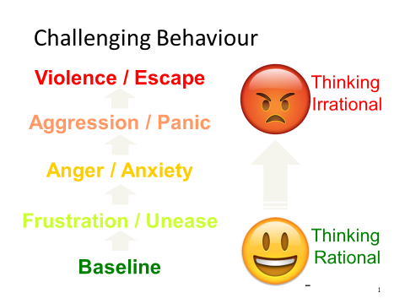

The fight-or-flight response
The fight-or-flight response, also known as the acute stress response, refers to a physiological reaction that occurs in the presence of something that is terrifying, either mentally or physically. The response is triggered by the release of hormones that prepare your body to either stay and deal with a threat or to run away to safety.
The term 'fight-or-flight' represents the choices that our ancient ancestors had when faced with a danger in their environment. They could either fight or flee. In either case, the physiological and psychological response to stress prepares the body to react to the danger.
What Happens During the Fight-or-Flight Response
In response to acute stress, the body's sympathetic nervous system is activated due to the sudden release of hormones. The sympathetic nervous systems stimulate the adrenal glands triggering the release of catecholamines, which include adrenaline and noradrenaline. This results in an increase in heart rate, blood pressure, and breathing rate. After the threat is gone, it takes between 20 to 60 minutes for the body to return to its pre-arousal levels.
When we are chronically afraid, we spend our emotional and mental energy on self-protection, such as lashing out in “fight” response, retreating in “flight” response, or becoming passive in “freeze” response. When we are reacting with survival responses we are not capable of being caring or empathic — even toward ourselves.
Further Reading:

www.harperwest.co/self-acceptance/five-factors/1-primal-threat/

What is the Drama Triangle?
Taken from - www.richerlifecounseling.com/persecutor-in-the-drama-triangle
Before diving into what the drama triangle looks like. First, think of any conflict between yourself and someone else. You both will play a role, and your role might change during the conflict. But if no resolution is quick coming, you will end the conflict feeling hopeless and lost. Dr. Karpman’s drama triangle list what is going on during the conflict.

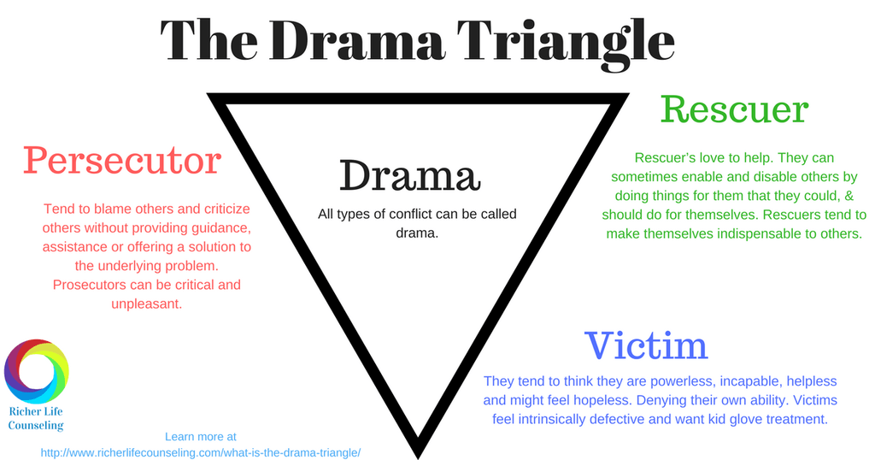

3 Types of roles that you can play in the drama triangle
Normally, you will always start off in a particular role. This is sometimes called a starting gate role, or I like to think of it as your on switch. Sometimes these roles can make up how you view yourself and your position in the relationship. These roles are not good or bad they are just ways we fit into conflict. The goal of each of these roles will be to learn to understand why you are in them, and how to change them to limit drama. These roles include:

Rescuer
Rescuer’s love to help. They can sometimes enable and disable others by doing things for them that they could, & should do for themselves. Rescuers tend to make themselves indispensable to others. Putting other’s needs before their own (my sacrificing relationships or family time to care for others) Feel guilt about saying no. Might even say things like “They won’t get it right away, I might as well do it myself.” Sometimes have the belief that they can ‘fix’ others. CLICK HERE to learn more about the rescuer role. What the starting gate rescuer looks like if they transition into other roles.

Persecutor
Persecutors tend to blame others and criticize others without providing guidance, assistance or offering a solution to the underlying problem. Prosecutors can be critical and patronizing. They can deny their own weakness, and focus on the weaknesses and problems of others. Lecturing, preaching, and criticizing with offensive, demeaning or sarcastic comments is how they communicate.
CLICK HERE to learn more about the persecutor role. What the starting gate persecutor looks like if they transition into other roles.

Victim
Victims are just like the name suggest victims to the drama. They tend to think they are powerless, incapable, helpless and might feel hopeless. Denying their own ability. Victims feel intrinsically defective and want kid glove treatment. When confronted with drama they might feel picked on, and not good enough. Sometimes sabotage others efforts to help. Victims can act like a martyr.
CLICK HERE to learn more about the victim role. What the starting gate victim looks like if they transition into other roles.

How The Drama Triangle Works
Each person in the conflict has a natural starting gate role. Depending on your relationship and your history your starting gate role might differ. My roles differ in my own life because in my marriage I fall into the persecutor role, yet when I think of conflict with my mother I am in the victim role.
No matter what your role, you will interact with each other based on your world view of that role. You can even change roles in the middle of a conflict. I might start off as a victim but turn the tables and become a persecutor.
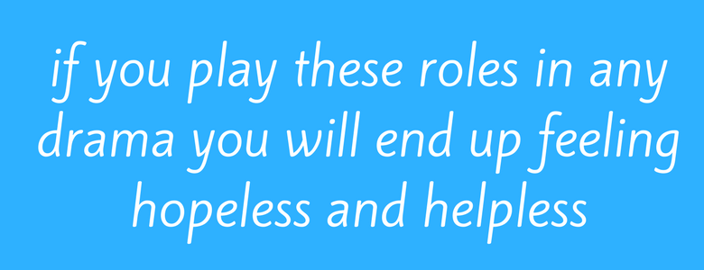

How To End The Drama Triangle

Rescuer becomes a Coach
Learn how to set boundaries with others. This starts with asking yourself the questions can they do this on their own? Only help when it is asked, and when the person asking for help is showing they are trying to do it on their own. Think of a good coach they push, inspire, teach BUT they do not play the game. CLICK HERE to learn more about the rescuer role can change.

Persecutor becomes a Challenger
Setting goals and having clear expectations is key to becoming a challenger. Learning how to set boundaries with others. Along with understanding what your own expectations are and learning how to ask for them directly. CLICK HERE to learn more about the persecutor role can change.

Victim becomes a Survivor
You must learn how to do things on your own. This starts with developing positive self-talk and keeping track of other things you have been successfully at. Set strategies to accomplish your goals. Take responsibility for your own actions, wants and needs.
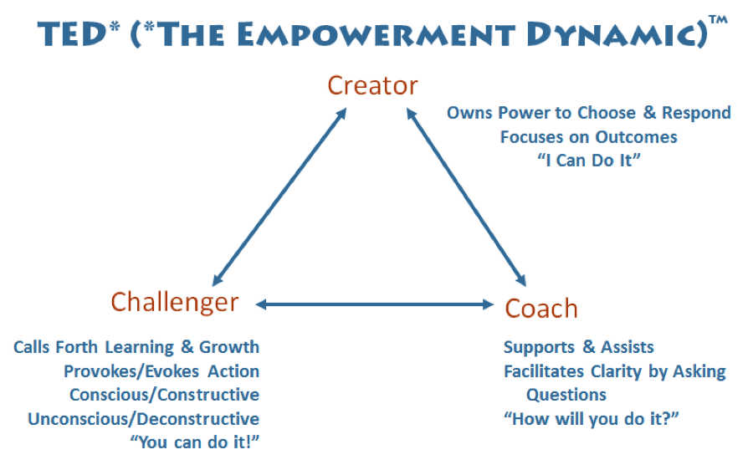

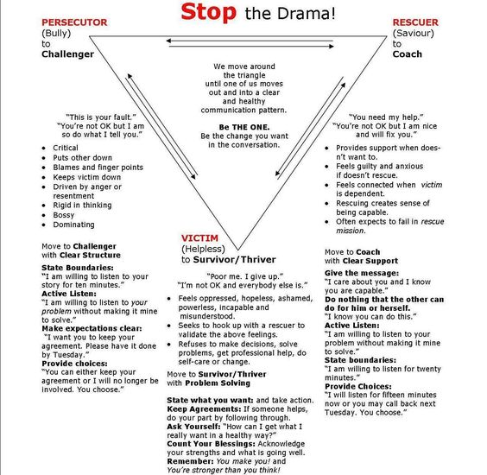
PLACE
Playfulness Creating a space that everyone wants to be in
Not at time of Crises
Love I’m here for you
We are connected
Acceptance That emotions are at that point over whelming and therefore so is behaviour
Curiosity Open questions – How can……
Empathy I can see that….
The aspiration - I’m Ok your OK
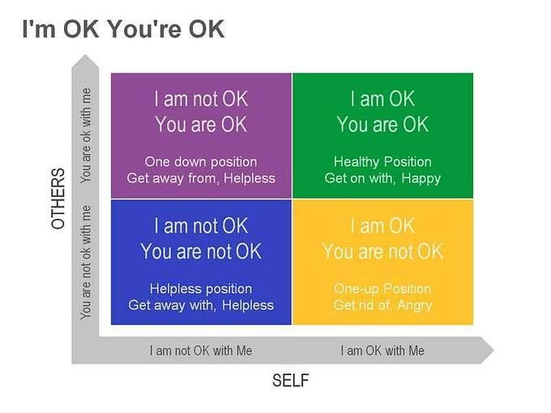
The Vicious Cycle
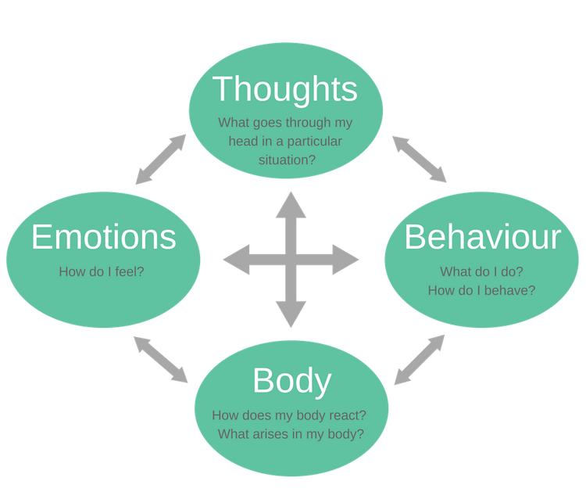
The Vicious Cycle is based on the Cognitive Behavioural Therapy model (CBT)
The cycle is the response to a situation (internal or external) and can sustain the situation.
Changing just one element can help to break the vicious cycles of negative thinking, feelings and behaviour. When you identify the different parts of the vicious cycle clearly, you can start to change them. Changing something in one part of the vicious cycle, will have a positive impact on the three other parts of the cycle and thereby start to create positive change.

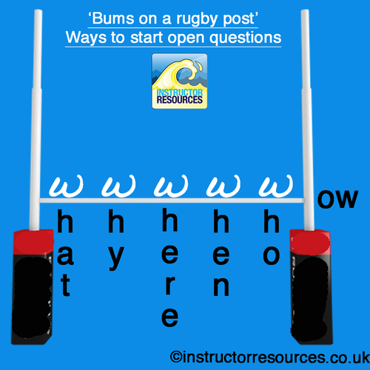
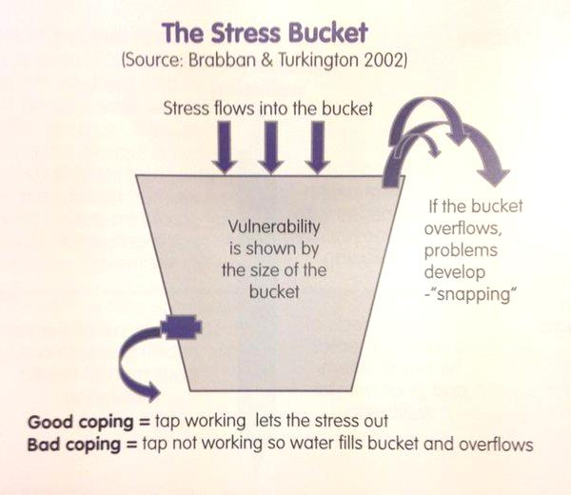

Note the tap or release valve which is a metaphor for ways of coping
Helpful coping strategies

Unhelpful coping strategies

Stress Bucket
1.What can I change?
2. What can’t I change and need to accept?
3. What needs my urgent attention?
4. Who can help me?

Helpful coping strategies

Containment
How to respond in an emotionally considered way to expressions of distress. Containment can happen between two people, or between a person and an organisation.
Reaching Out
The person projects feelings and experiences which are difficult to put into words onto the container.
Example: Shouting in distress after an event.
Result
The person feels supported and valued, and has space to feel calmer. They are more likely to talk to the container again in future.
Responding appropriately
Once the feelings or experiences have been processed, the container then figures out how to respond.
Example: ‘I can see that you’re feeling distressed about this. Would you like to talk about it?’
Observing the situation
The container (people) notice details of what has happened and tries to make sense of it.
Example: Taking some time to process what’s been happening and consider the person’s feelings.
Taking Space
The container takes the projected feeling or experience, and does not react immediately.

Example: Not taking a step back in fear or recoiling.

Gibbs' Reflective Cycle
Many people find that they learn best from experience.
However, if they don't reflect on their experience, and if they don't consciously think about how they could do better next time, it's hard for them to learn anything at all.
This is where Gibbs' Reflective Cycle is useful. You can use it to help your people make sense of situations at work, so that they can understand what they did well and what they could do better in the future.

About the Model
Professor Graham Gibbs published his Reflective Cycle in his 1988 book "Learning by Doing." It's particularly useful for helping people learn from situations that they experience regularly, especially when these don't go well.
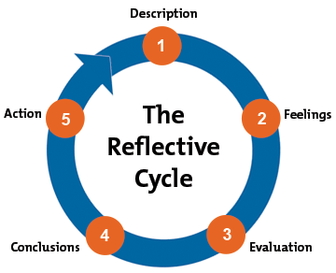

Using the Model
You can use the model to explore a situation yourself, or you can use it with someone you're coaching – we look at coaching use in this article, but you can apply the same approach when you're on your own.
To structure a coaching session using Gibbs' Cycle, choose a situation to analyze and then work through the steps below.

Step 1: Description
First, ask the person you're coaching to describe the situation in detail. At this stage, you simply want to know what happened – you'll draw conclusions later.
Consider asking questions like these to help them describe the situation:
- When and where did this happen?
- Why were you there?
- Who else was there?
- What happened?
- What did you do?
- What did other people do?
- What was the result of this situation?

Step 2: Feelings
Next, encourage him to talk about what he thought and felt during the experience. At this stage, avoid commenting on his emotions.
Use questions like these to guide the discussion:
- What did you feel before this situation took place?
- What did you feel while this situation took place?
- What do you think other people felt during this situation?
- What did you feel after the situation?
- What do you think about the situation now?
- What do you think other people feel about the situation now?

Step 3: Evaluation
Now you need to encourage the person you're coaching to look objectively at what approaches worked, and which ones didn't.
Ask:
- What was positive about this situation?
- What was negative?
- What went well?
- What didn't go so well?
- What did you and other people do to contribute to the situation (either positively or negatively)?

Step 4: Conclusions
Once you've evaluated the situation, you can help your team member draw conclusions about what happened.

Encourage them to think about the situation again, using the information that you've collected so far. Then ask questions like these:
- How could this have been a more positive experience for everyone involved?
- If you were faced with the same situation again, what would you do differently?
- What skills do you need to develop, so that you can handle this type of situation better?

Step 5: Action
You should now have some possible actions that your team member can take to deal with similar situations more effectively in the future.
In this last stage, you need to come up with a plan so that he can make these changes.
Once you've identified the areas he will work on, get him to commit to taking action, and agree a date on which you will both review progress.

Note:
Gibbs' original model had six stages. The stage we haven't covered here is "Analysis" – we've included this as part of the Evaluation stage.
www.mindtools.com/pages/article/reflective-cycle.htm

Action Learning Set (Group)
Action Learning is “Essentially facilitated peer-learning and problem solving using a discipline of uninterrupted presentation, open questioning and summary – effectively a form of group coaching". (The Independent Theatre Council)
Action learning is a development opportunity where you have time to focus on what is important to you. It might be problem solving, strategic management, reflective practice or managing change. The focus can be individual professional development or organisation development. You meet with a group of peers. What you have in common is the need for structured time to reflect and to share learning. For more information Click here

What actually happens in an action learning set?
A group of between 4 - 8 people working in related fields and at comparable levels of responsibility, meet regularly for a contracted number of meetings, which is usually five, over twelve to eighteen months. Initially you work with an external facilitator who acts as catalyst and coordinator, supporting you throughout this process. At the end of the initial contract, you as group members decide whether or not to continue meeting for a further contracted period, and whether to work on your own or with a facilitator.
At each meeting there is a disciplined process:
- every set member reports briefly on what has been happening
- set members decide who is going to present a particular situation that they currently face
- the presenter talks, for as long as he/she wishes, and describes their situation/dilemma/ challenge
- the set members ask questions designed to assist the presenter come to a deeper understanding
- set members do not give advice, tell anecdotes, pass judgement, or talk about how it compares to their own situation
- the set assists the presenter to review options and decide on action
- the set reflects on the group process and gives feedback to each other on what has taken place
- at a future set meeting, the presenter reports back on the action taken.

The facilitator:
- enables the group to reflect on group processes
- creates safety for individual members to explore sensitive issues
- takes the group beyond superficial analysis
- keeps the group focused on the individual presenter
- ensures that group members follow action learning conventions
- enables the group to draw out general lessons on management development.

Action learning
Legend has the father of action learning, Reg Revans, sitting in the HQ of the newly nationalised coal industry. In the brave new world that was 1946, people were enthusiastic about modernising what had previously been a collection of individually owned mines with pretty variable standards of this and that. There was talk of improving those standards, talk of training, talk of a University of Coal. Revans decided to see if there were good things happening already - out in the field.
What he discovered was that highly productive mines tended to occur in clusters and that their productivity wasn't a function of geology (i.e. the mines all tapping the same rich veins of coal). What he unearthed, so to speak, was that in the productive clusters the undermanagers (yes – that's what they call the chaps who manage what's under) had formed the habit of getting together for a pint at the local on a Friday night to talk over the week's problems.
"A group of people running similar organisations, meeting regularly to listen to each other's problems and to offer advice. Action learning is as simple as that."
And this getting together to chew the cud is what later became known as an action learning set: a group of people running similar organisations, meeting regularly to listen to each other's problems and to offer advice. Action learning is as simple as that. Later some argued for the presence of a facilitator, but my own view is that the local's atmosphere and ale are facilitation enough. There is a terrible temptation, for all parties, to turn the facilitator into the authority figure who guides the discussion and has the answers.
Excited by the power and simplicity of his finding, so the story goes, Reg sought an audience with the cabinet minister in charge of the coal industry. Going into the great man's office he recognised the vice chancellor of one of the great universities coming out. Bubbling with excitement he told Reg that a group of universities he represented had just been given £100m to set up a University of Coal. In vain Reg tried to explain to the great man that he could save him £100m and get better, quicker results. The idea of action learning was altogether too simple to be believed.
Whether in a huff or not, Revans moved to Belgium where he headed the Inter-University project, which had been set up to improve the ranking of Belgium in the OECD. Working with five universities and 23 of the country's largest businesses, Revans' collaborative approaches succeeded in raising the growth rate of Belgium's industrial productivity above that of the USA, Germany, Japan and, of course, Britain.

