What should I do if I’m interested?
We would love to hear from you if you think you might be interested in working with us. You can request more information by filling in and returning the form below. You also can contact the coordinator of the PPE involvement at the University directly:
Vuokko Wallace, Clinical Psychologist
Clinical Psychology training programme
University of Bath
Department of Clinical Psychology
Claverton Down, Bath BA2 7A
tel. 01225 38 3096
v.wallace@bath.ac.uk

I……………………………………………………………. would like some more information about being involved in the following areas of the Clinical Psychology Training Programme:

Teaching
Committees
Research
Admissions

Email: …….………………………………………………….

Tel no: ………………………………………………………….

People with Personal Experience

People with personal experience of psychological difficulties, and/or personal experience of psychological therapy.

Our PPEs include people who might have physical health or neurological difficulties that cause distress and bring them into contact with clinical psychologists.

Our PPEs also include carers and people who may not have experienced a psychological difficulty themselves, but have supported a loved one in going through such an experience and accessing services provided by clinical psychologists.

For more information:

Doctorate in Clinical Psychology Course
http://www.bath.ac.uk/psychology/clinical/
tel. 01225 38 3096
v.wallace@bath.ac.uk

Would you like to share your experiences of psychological difficulties to help us train future clinical psychologists?

The University of Bath provides professional post graduate training for psychologists. The Doctorate in Clinical Psychology is a three year training programme, which includes academic study and clinical placements in the NHS mental health services. The training programme is strongly committed to working together with people with personal experience. The term People with Personal Experience (PPE) was chosen by PPE representatives to describe people with experience of a range of psychological or physical health difficulties including addiction, anxiety, depression, learning difficulties and relational issues. It also includes carers and people who may not have themselves experienced a psychological difficulty but have supported a loved one.
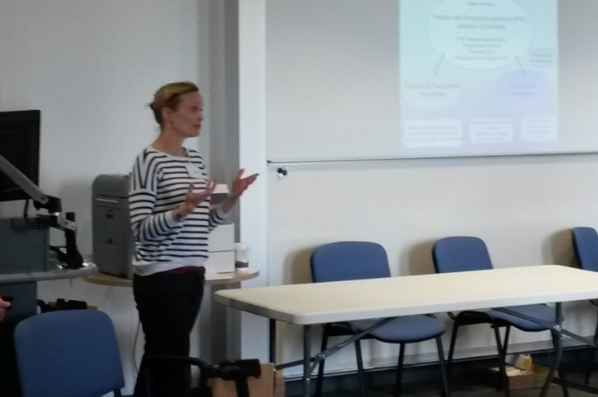
Why involve PPE in the Clinical Psychology Trainee Programme?
We know that there is still much to be done to improve health services and make them more accessible and helpful for people. We hope that by working together with PPEs on the Programme, we can foster attitudes and practices that serve trainees well in all the different contexts that they will find themselves working in. We want the contribution of PPEs to be challenging and thought-provoking for trainees, and we feel it is important to include this unique perspective from the very beginning of training and in a wide variety of ways.
What can PPEs be involved in?
PPE involvement in the programme is an ongoing process that continues to develop. There are many different possibilities, but these broadly fall into the four categories of: helping to shape and deliver teaching to trainees; helping trainees design and pilot their research projects; involvement in various Programme committees; helping select people to train as clinical psychologists. We continue to look into new ways of how PPEs can contribute to our programme.
Will I be paid?

The Programme is pleased to be able to offer payment per hour for PPE involvement. Unfortunately, we cannot pay for time spent travelling but we can cover travel costs. Please speak to us if you need the support of an assistant or carer to enable you to get involved and we will help in whatever way we can.
What are the benefits?
“I have gained an enormous amount from being involved on the course; my confidence has really improved! I've found it very validating but it's also helped give meaning to many very difficult years to help trainees who will go on to help many hundreds or thousands of patients during their career really 'get' what severe mental health issues feel like” - PPE
“I think PPE involvement in the course is incredibly important. There is no-one better placed to help us understand the realities of mental health difficulties.” - Trainee
“I have been involved in various committees including admissions, practice and placement, the programme committee and the PPE committee as well as working groups. I've also been involved in various teaching sessions and in a number of trainee research projects…I love all of the various types of involvement and have learnt a huge amount! I have also always felt very much respected and valued and feel Bath really do want to hear our perspective!” – PPE
“It's hard to overstate the importance of the contribution of PPE. Losing this would lose a critical perspective on mental health/the role of clinical psychology.” – Trainee

“To anyone considering becoming a PPE I'd definitely suggest you try it!! You may love one area but not another but I'd really encourage you to give it a go!!” – PPE

People with personal experience and service user involvement in the mental health services
Together for mental wellbeing charity described service user involvement as being about “…making sure that mental health services, organisations and policies are led and shaped by the people best placed to know what works: people who use mental health services. They are experts by experience.” (Together/nsun, p. 1, 2014)

We strongly believe that in order to achieve change in the mental health system, training of future clinical psychologists should incorporate the expertise of people with personal experience, and partnership between health professionals and service users.

“Increasingly, meaningful involvement of people who use—or have used—services is being recognised as an indispensable part of mental health service delivery. When people are equipped and supported to help commission, deliver and check the services they and their peers use, those services improve and the people involved gain in confidence and skills.” (Together/nsun, p. 1, 2014)

Reference: Together/nsun (2014). Service user involvement in the delivery of mental health services, May 2014. (Accessed from: http://www.together-uk.org/wp-content/uploads/downloads/2014/06/Service-User-Involvement-briefing.pdf)

